**Bool**

Store Boolean data into bool data type which can only store True or false.

Bool variable can only have true or false as valid value. If we try to store any other values it will throw error at compile time.

**Integer, float, decimal**



Values that different data types can store are as shown below.

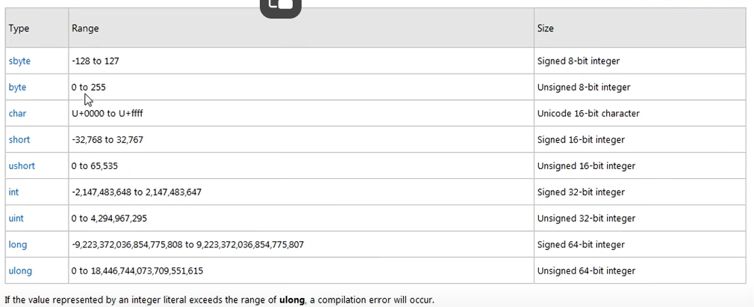

We also have float and double data types that can store decimal values.

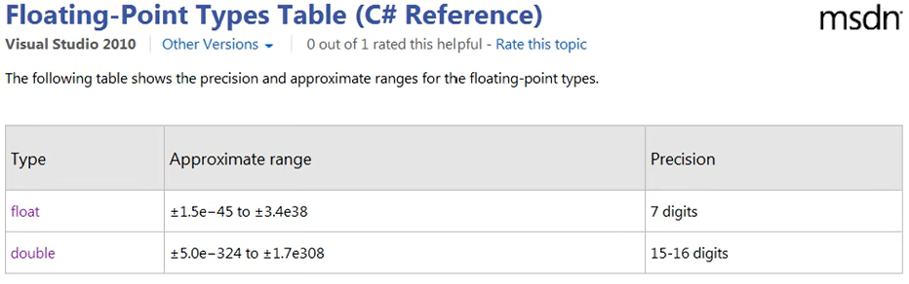

**String Type**

Escape sequence and verbatim to style and use special character.

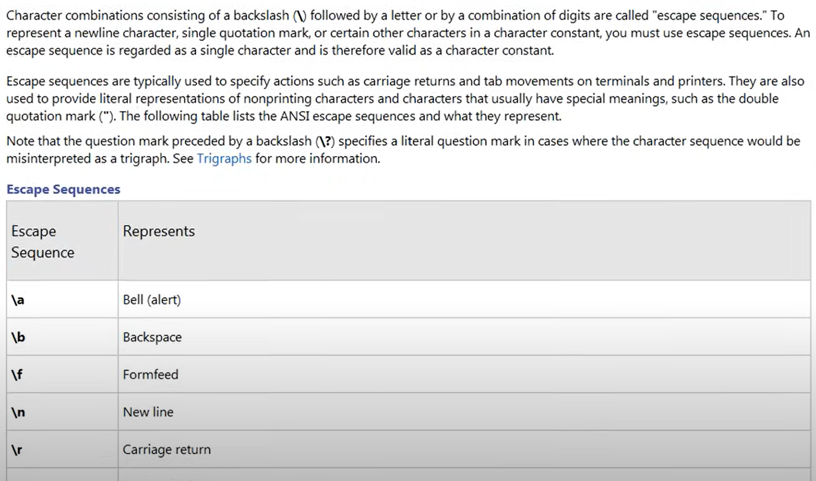

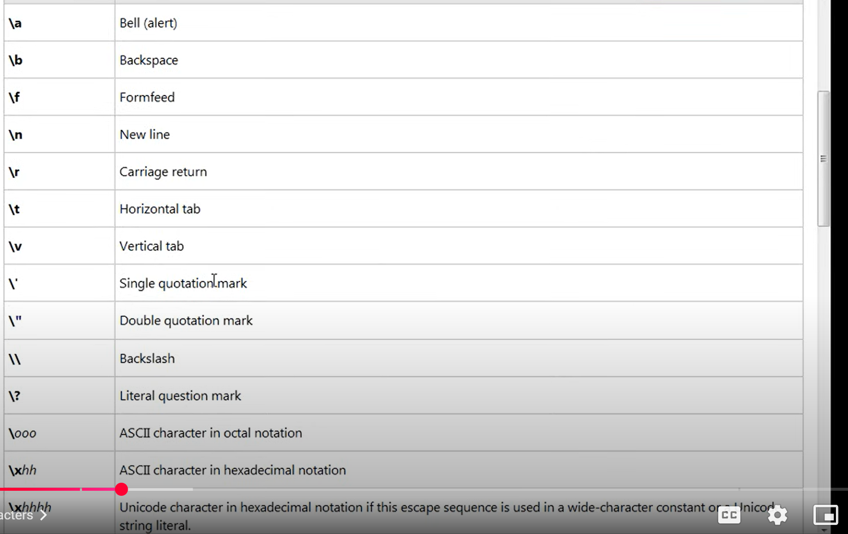

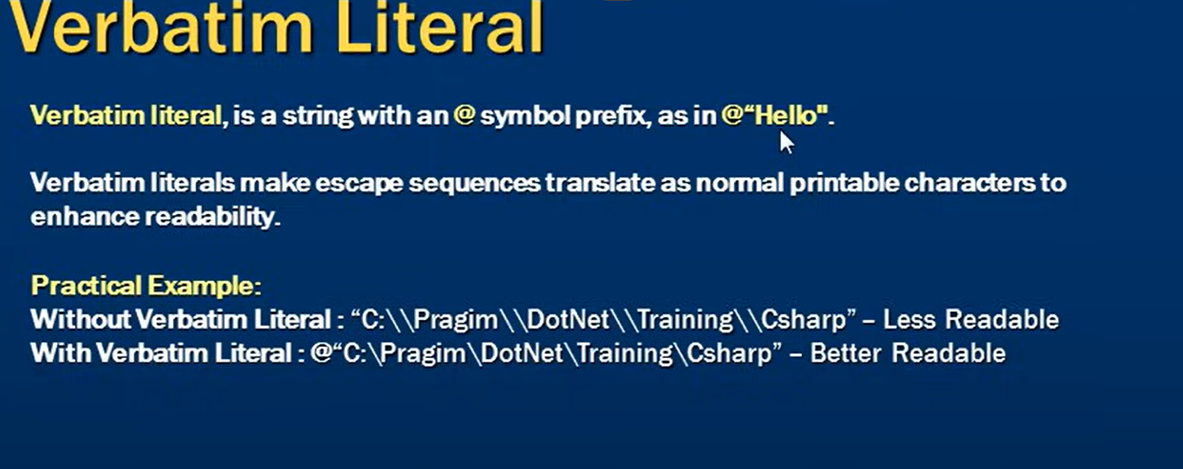

Karichand, rabrish , ramprit – CA delhi – final exam dele hai .